Solitary Meditation Retreat for Female Practitioners at Giac Tam Meditation Center
*To register, please fill out the form here: https://forms.gle/JPpbXJmTpJQzjbV39
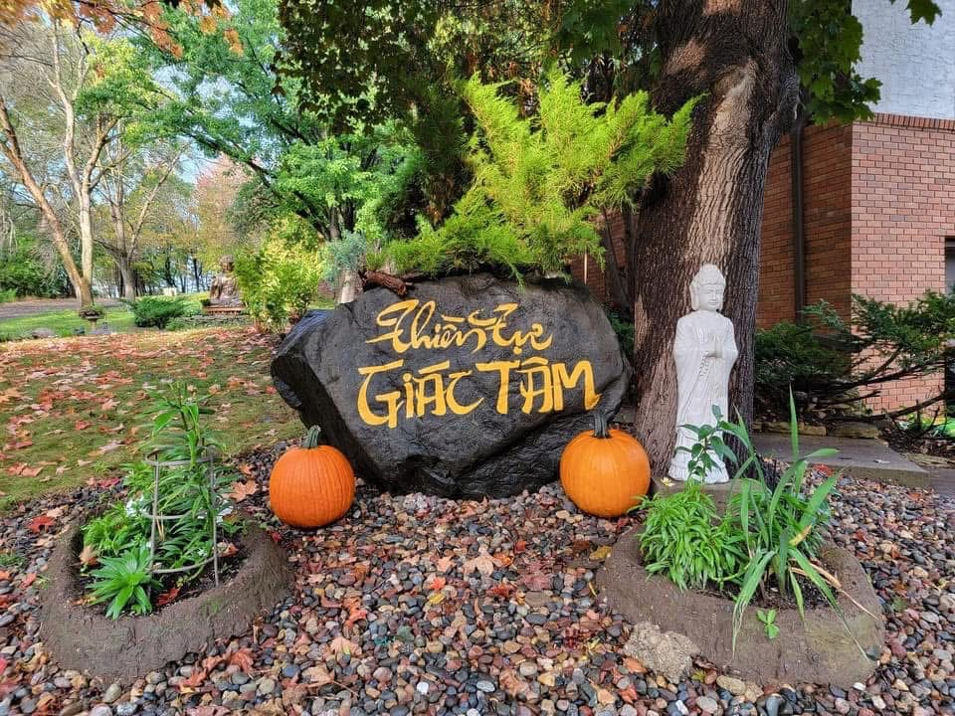
Why Choose a Solitary Meditation Retreat Practice?
Solitary meditation retreat holds profound significance in spiritual practice, providing a unique opportunity for deep self-reflection, insight, and inner transformation. By withdrawing from external distractions and engaging in extended periods of silence and contemplation, practitioners can cultivate mindfulness, clarity, and a direct experience of their true nature.
The Vietnamese Bamboo Forest Zen tradition places special emphasis on the value of solitary retreat, viewing it as an essential aspect of personal and spiritual development. Within this tradition, monastics are strongly encouraged to undertake one solitary retreat each year. The recommended progression begins with a two-week period of isolation, gradually extending to one month, then forty-nine days, three months, and eventually up to six months. This step-by-step approach allows practitioners to build resilience, deepen their meditation practice, and experience the transformative benefits of solitude. Through this disciplined practice, individuals nurture wisdom, compassion, and equanimity—qualities central to the Zen path.
While monastics are encouraged to take part in these retreats, lay practitioners are also welcome and encouraged to participate in solitary retreats to receive similar benefits. Even with the many responsibilities and demands of daily life, laypeople can find immense value in carving out time for solitude and reflection. It is recommended that lay practitioners schedule several short-term retreats throughout the year as their schedule allows—beginning with a weekend, then gradually increasing to four days, a week, ten days, two weeks, or even a month. Despite the busy nature of modern life, opportunities for solitary retreat are especially vital to help bring calmness, peace, clarity, and balance into one’s life.
Preparing to Enter Solitary Retreat
Thoughtful preparation is essential for a successful solitary meditation retreat. Begin by informing family, friends, and colleagues of your retreat dates to minimize outside obligations and interruptions. Make arrangements to handle pressing responsibilities and set clear boundaries around your availability so you can fully dedicate yourself to the experience.
In the days leading up to the retreat, gradually reduce digital and social media use to help your mind transition into a quieter state. Pack simple, comfortable clothing, meditation supplies, and any personal items that foster a sense of ease and stability. Reflect on your intentions and aspirations for the retreat, writing them down if helpful, and approach this period with openness, patience, and a spirit of gentle self-care. By preparing both practically and mentally, you create the conditions for deep rest, insight, and renewal.

Guidelines for Lay Practitioners during Solitary Retreat
What to Wear: For maximum comfort and ease during your solitary retreat, choose loose-fitting, modest clothing in neutral or earth tones. Simple attire such as long-sleeve shirts, sweatpants, or traditional meditation robes is recommended to minimize distraction and support a contemplative atmosphere. Avoid flashy patterns, tight clothing, or jewelry, which can draw attention away from your practice.
Routine Activities: Establish a daily schedule that includes periods for meditation, mindful movement (such as gentle yoga or walking meditation), meals, and personal care. Begin your day with a short sitting meditation, followed by mindful stretching or yoga, and then breakfast. Alternate periods of seated and walking meditation throughout the day, interspersed with time for reading spiritual texts, journaling, or silent reflection. Maintain a calm and orderly Zen Den room and follow simple rituals such as making your bed or cleaning your space with mindfulness. Limit use of electronics and avoid unnecessary communication to preserve the solitude of the retreat.
Mindful Practice: Approach all activities with present-moment awareness, gently bringing your attention back to your breath or body sensations whenever the mind wanders. During meditation, observe thoughts and emotions without judgment, allowing them to arise and pass naturally. Use the solitude to deepen self-inquiry, cultivate compassion, and develop equanimity. If challenges or discomfort arise, acknowledge them with kindness and patience, viewing them as opportunities for growth. Dedicate time each day for gratitude and setting intentions, allowing these practices to support your inner transformation and clarity.
Post-Retreat Integration: Returning to Daily Life with Mindfulness
After completing a solitary meditation retreat, it is essential to transition mindfully back into everyday routines to sustain the insights and peace cultivated during your time in solitude. Rather than rushing to resume all previous activities at once, allow yourself time to gently re-enter your daily schedule. Start by intentionally maintaining a simplified routine for several days after your retreat, prioritizing self-care and continued periods of silence or meditation each morning and evening.
Carry forward the spirit of mindfulness by integrating brief pauses throughout your day—such as mindful breathing before meals, taking a few conscious breaths at stoplights, or practicing gratitude before sleep. When responsibilities or social interactions begin to feel overwhelming, use these mindful moments to ground yourself and reconnect with the calm awareness you cultivated in retreat. Be compassionate with yourself, acknowledging that it is natural for distractions and busyness to arise, and gently return your attention to the present moment whenever you notice your mind wandering.
Consider journaling about your transition, noting what supports your ongoing practice and where you might need additional care. If possible, stay in touch with a meditation teacher or spiritual community for encouragement and accountability. By weaving these small, consistent practices into your everyday life, you can sustain the clarity, equanimity, and deep presence gained during your solitary retreat—enriching both your own well-being and your interactions with others.

Frequently Asked Questions (FAQs) for Solitary Retreat
- Do I need prior meditation experience to attend a solitary retreat? Although having previous meditation experience can be beneficial, it isn’t a strict requirement. However, individuals preparing for a solitary retreat should possess at least some basic understanding of Buddhism and meditation practices. Numerous centers, such as Giac Tam Meditation Center, provide tailored guidance or beginner courses in Buddhism and meditation to support newcomers as they get started.
- What should I bring with me? Bring simple, comfortable clothing, personal toiletries, and any favorite meditation supplies (such as cushions or yoga mats). You may also wish to bring a journal, spiritual reading materials, and snacks if desired. Most necessities for comfort and practice are provided by the center.
- Is there Internet or cell phone use during the retreat? Guests are encouraged to minimize or completely refrain from digital device use during the retreat to support deep focus and solitude. Emergency contact details can be shared with loved ones ahead of time if needed.
- What if I feel lonely or face emotional challenges? Feelings of loneliness or discomfort can be a natural part of solitary practice. Approach these experiences with patience and self-compassion. If needed, support is available through scheduled consultations with the resident nun or teacher.
- Are there any restrictions on food or dietary accommodations? Vegan meals are typically provided, and most dietary needs can be accommodated with advance notice. Guests are welcome to bring personal snacks or items as needed.
- Can I leave the retreat early if necessary? While it is best to complete the planned retreat for the most benefit, participants can leave early in case of emergency or unforeseen circumstances. Please communicate with the retreat host if your plans change.
- What is the daily schedule like? The retreat schedule typically balances periods of sitting and walking meditation, mindful movement, meals, and personal reflection. Flexibility is allowed to accommodate individual needs while maintaining a structured, mindful environment.
- How can I best prepare for my retreat? Begin reducing digital and social engagement ahead of time, inform loved ones, and attend to responsibilities. Reflect on your intentions and approach the experience with openness and gentle self-care.
- Can I use candles or incense during my stay? Guests may use candles or incense sparingly to prevent triggering the sensitive smoke alarm. Guests can open windows for ventilation but make sure the mesh screen remains intact.
- Are there any recommended books for a solitary retreat? Some highly regarded books for solitary retreat include Zen Mind, Beginner’s Mind by Shunryu Suzuki, The Miracle of Mindfulness by Thich Nhat Hanh, and Wherever You Go, There You Are by Jon Kabat-Zinn. These works offer practical insight and inspiration for deepening meditation and mindfulness during your retreat. You may also benefit from bringing a journal to record reflections and observations throughout your experience.
----------------------------- ***-----------------------------
Solitary Retreat Overview at Giac Tam Meditation Center
The Giac Tam Meditation Center, a sister branch of the Dai Dang Headquarter Monastery in California, is situated at 3729 Pilot Knob Road, Eagan, Minnesota 55122. Set on two acres of serene woodland, the center is conveniently located just 20 minutes from the Minneapolis–Saint Paul International Airport and close to major business districts, while still providing a peaceful, secluded environment. Established nearly 15 years ago, the center has been meticulously maintained and thoughtfully cared for by the resident Buddhist sister nuns. This setting offers an ideal environment for female practitioners seeking a tranquil and solitary meditation retreat.

Accommodations
Each guest is provided with a private Zen Den room on the second floor, ensuring both privacy and a supportive atmosphere for personal reflection and practice. The full bathroom is shared with the resident nun, fostering a sense of community and mutual support. Zen Den rooms are thoughtfully designed to offer comfort and convenience, featuring a single bed with pillows and blankets, meditation cushions, a yoga mat, and a space heater. For added convenience, amenities for breakfast preparation and light refreshments include a microwave, toaster, mini-fridge, water boiler kettle, filtered water, tea, and condiments. Guests are also welcome to bring their own personal blankets, pillows, yoga mats, meditation cushions, and snacks if they prefer, allowing for extra comfort and familiarity during their stay.

Practice Support
Throughout the retreat, guests have the opportunity to arrange a personalized, one-hour Zen Meditation Lesson or Practice Consultation with the resident sister nun. This individualized guidance is designed to deepen meditation skills and foster spiritual development.

Meals
Nutritious vegan lunches and light, medicinal dinners are prepared upon request by the nuns. Meals may be enjoyed either in the company of the nuns or privately in one’s room, offering flexibility to accommodate individual preferences.

Duration of Stay
· Minimum stay: 2 days
· Maximum stay: 2 weeks
(Advance registration is required to secure accommodations).
*To register, please fill out the form here: https://forms.gle/JPpbXJmTpJQzjbV39

Check-In and Check-Out
· Check-in: 9:00 AM
· Check-out: 4:00 PM

Retreat Policy
- Smoking is strictly prohibited in all areas of the facility, both indoors and outdoors, to ensure a healthy and respectful environment for all guests and residents.
- Pets are not permitted on the premises under any circumstances. This policy is in place to maintain a peaceful atmosphere and to respect the needs and safety of all participants, including those with allergies or sensitivities.
- All guests are expected to observe noble silence and maintain an atmosphere of tranquility throughout their stay. This includes refraining from unnecessary conversation, keeping electronic devices on silent, and showing mindfulness in all activities, to support the contemplative nature of the retreat.
- Guests are required to keep their rooms and shared spaces tidy and in the same condition as they were upon arrival. Please dispose of waste appropriately, return items to their proper places, and inform staff of any damages or maintenance needs.
- All lights must be turned off by 10:30 PM to promote restful sleep for everyone and to honor the community’s quiet hours. Please ensure that your activities conclude prior to this time.
- Please show respect for all meditation halls, practice rooms, and the monastery grounds. This includes following posted guidelines, refraining from disruptive behavior, and treating all facilities and natural spaces with care and reverence.
- For privacy and security reasons, all guests must enter and exit the building exclusively through the front door. Please do not use side or back entrances unless directed by staff in case of emergency.
- When outdoors, please remain within the boundaries of the monastery property and do not trespass onto neighboring lands. This policy ensures respect for the privacy and property of our neighbors and maintains good community relations.

Registration and Pre-Requisite
All guests are required to have some prior familiarity with Buddhism and meditation practice before beginning a solitary retreat. After submitting their application, each guest must schedule a 30-minute one-on-one Zoom meeting with Sister Pearl. This meeting ensures that the monastic sister nuns can support the guest’s practice during their stay and provides an opportunity to address any questions or concerns in advance.
*To register, please fill out the form here: https://forms.gle/JPpbXJmTpJQzjbV39
Fee / Donation
Giac Tam Meditation Center is a registered 501(c)3 tax-exempt nonprofit organization operated entirely by volunteers. The center upholds the Buddhist tradition by offering all programs without charge, ensuring that opportunities for solitude and spiritual development are accessible to all. While participation does not require any payment, guests are cordially invited to practice generosity (dana) through voluntary donations—a foundational Buddhist value that nurtures compassion and joy, sustains the Sangha, and supports the ongoing vitality of the Dharma. A suggested donation amount of $90 per day will offset essential expenses such as room and board, enabling the center to continue providing retreat experiences for future participants. Recognizing that financial circumstances vary, we encourage those who are able to contribute more, thereby fostering increased accessibility for individuals from economically marginalized communities.

Disclaimer
Giac Tam Meditation Center is not liable for any health issues, illness, accidents, or injuries that may occur during your stay. By participating in activities or residing at Giac Tam Meditation Center, you acknowledge and accept full responsibility for your personal health and safety. The Center does not provide medical services and cannot be held accountable for any medical emergencies, pre-existing conditions, or unforeseen incidents that might arise during your visit. All guests are encouraged to consult with their healthcare providers before engaging in meditation or retreat activities, and to carry any necessary medications or medical devices. In the event of an emergency, local authorities and medical professionals should be contacted immediately. The Center also disclaims liability for loss or damage to personal property. By entering the premises, you agree to release Giac Tam Meditation Center, its staff, and volunteers from any claims related to injury, illness, or accident, whether occurring on the grounds or while participating in Center-sponsored events.

Contact Information
For further inquiry, please email: giactamcommunity@gmail.com

